- Connect BBB and PC via USB serial cable.
Refer http://pillsfromtheweb.blogspot.com/2016/03/connect-beaglebone-black-and-mac-os-x.html

Note: If using virtualbox to run Ubuntu Virtual machine: Please config as below

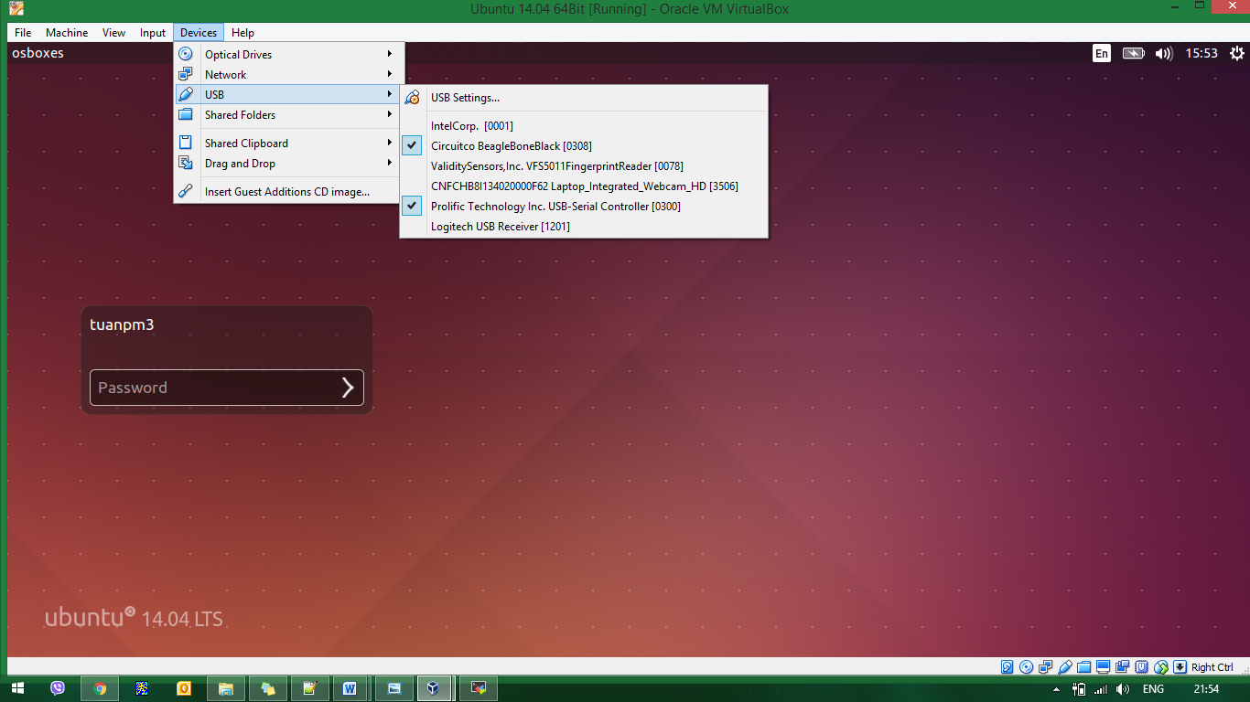

- On Ubuntu
- Setting for minicom
$ sudo minicom –s

setting as below (press A, B, C…G to setting):

+-----------------------------------------------------------------------+
| A - Serial Device : /dev/ ttyUSB0 (or ttyUSB1) |
| B - Lockfile Location : /var/lock |
| C - Callin Program : |
| D - Callout Program : |
| E - Bps/Par/Bits : 115200 8N1 |
| F - Hardware Flow Control : No |
| G - Software Flow Control : No |
| |
| Change which setting? |
+-----------------------------------------------------------------------+

press Enter → Save setup as dfl → Exit from Minicom

- Start minicom
$ sudo minicom

Welcome to minicom 2.7

OPTIONS: I18n
Compiled on Jan 1 2014, 17:13:19.
Port /dev/ttyUSB0, 15:51:24

Press CTRL-A Z for help on special keys

Note: if ttyUSB0 is locked. Do following
$ sudo minicom –S ttyUSB0 -o

